Beer Name: tire biter bitter
Brew Date: Mar 11’18
Batch Size: 10 gal
Target OG/◦ 1.046
Amnt lb/kg Ingredient
10 # ESB
2.75 # Crystal 60/80
3 # Bisquit
1 # Wheat
1 tsp NaCl(mash)
1 tsp NaCl(sparge)
5 tsp supercharge
2 tabs irish moss

Qt oz/g Hop/Seasoning Time

28 g NB 60min
14 g Golding 30min
14 g Golding 15min
2 tabs irish moss
Stage Date
Primary:
Racked:
Racked:
Bottled:
Kegged:
Re-Kegged:
Purged: Charged:

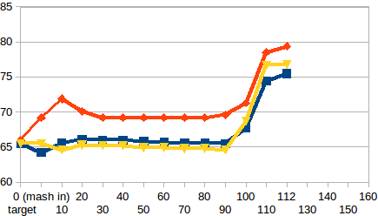
Start Time: 7am
Fill mash tun: Sat
Fill sparge kettle: Sat
Fire burners: 7am
Heat Mash Tun : Target Temp: 65.5
Heat Sparge Kettle: Target Temp: 66
Target Temp (Mash): 65.5
Grind grain: 8am
sparge temp:69.5
Strike Temp: 65.5
pump temp: 65.5
Temp: 64.2
Mash: Duration: 90 minutes
Start: 8:15am Finish: 9:45am
Heat (to deactivate enzymes)
Target Temp: 75.5
Start: 9:45am
Finish: 10:07am
Heat Sparge H20 (Target80◦)
Sparge:
Start: 10:17am Finish: 11 am
Wort collected: up to rivets in boiler
Boil : Burner On:
Rolling Boil: 11:25 am
Hops In: 11:55am
Hops In: 12:25pm Hops-whirlflock In: 12:40pm
Duration: 90 min
Start: 11:25am Finish: 12:55 pm
Burner Off:
Rest 15 min
Start: 12:55 Finish: 1:10 pm
OG : 1.045
Yeast: Nottingham Yeast
Irish Moss
Pump&Chill:Start:1:15 Fin: 1:40pm
Clean&San: Start: 1:40 Fin: 2:45
Notes: less grain/less temp drop at mash in

